NBS SPECIFICATION
N10 General Fixtures/Furnishings/Equipment
Laminate Worktop with Integral Coved Upstand
PROJECT  [Insert project name] | PREPARED FOR  [Architect / Contractor] | DATE  November 2026 | REVISION / STATUS  A — For Approval
200 WORKTOPS — LAMINATE WITH COVED UPSTAND
Location | Refer to Architect's drawings.
Manufacturer | Bridgewater Direct, Unit 1C Britannia Business Park, Union Road, Bolton BL2 2HP. Tel: 0161 703 3980 · sales@bridgewaterdirect.co.uk · www.bridgewaterdirect.co.uk
Product reference | Laminate Worktop with Integral Coved Upstand — 40 mm core, 75 mm coved upstand
Construction | 40 mm chipboard core faced in non-porous, wipe-clean high-pressure laminate (HPL).
Rear upstand | 75 mm integral coved upstand, formed in one piece with the worktop surface, with no seam at the back edge. 115 mm overall height.
Front edge & ends | Postformed front edge. Both ends capped.
Size, to the millimetre | Width 400–2900 mm, wall to wall. Depth 400–900 mm, including the upstand.
Cut-outs & joints | Sink cut-outs, tap holes, joints and non-standard layouts quoted from the project drawing.
HTM 63 status | Not supplied as an HTM 63 product and carries no hygiene certification. Where the specification names HTM 63, use the Bridgewater Direct HTM 63 Laminate Worktop.
Colour (Architect to select) | BD White, BD Dove Grey, BD Graphite, BD Natural Oak, BD Pearl Stone or BD Slate Stone.
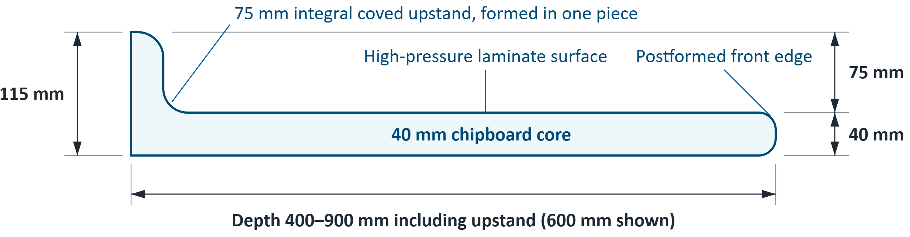
Section through the worktop, 600 mm depth shown. Upstand thickness and radii are indicative: refer to the manufacturer.
INSTALLATION
- Programming: Do not install until the building is weathertight and dried out and wet trades have finished.
- Measuring: Wall to wall at the back, then front to back at the deepest point. Confirm before manufacture.
- Modifications: Do not cut, plane or sand prefinished components. Seal all edges of any opening cut on site.
- Fixing by others: Secure to the supporting units or framework and seal the upstand to the wall.
- Moisture and movement: Make adequate allowance for future movement.
SAMPLES & TECHNICAL SUPPORT
Decor samples, datasheets and project advice are available direct from Bridgewater Direct: call 0161 703 3980 or email sales@bridgewaterdirect.co.uk quoting the product reference above, or configure online at www.bridgewaterdirect.co.uk.

